**COMSATS University Islamabad (CUI)**

**Abbottabad Campus**

**Department of Computer Science**



**Assignment # 01**

**Submitted By**

**Group Members Registration Number**

Saifullah Khan Jadoon SP24-BCS-108

Saifullah SP24-BCS-107

Sikandar dar SP24-BCS-114

**Course Title** Artificial Intelligence

**Program** BS Computer Science

**Submitted To** Mam Maleeha Khalid

**Submission Date** 30th September,2025

Question 1

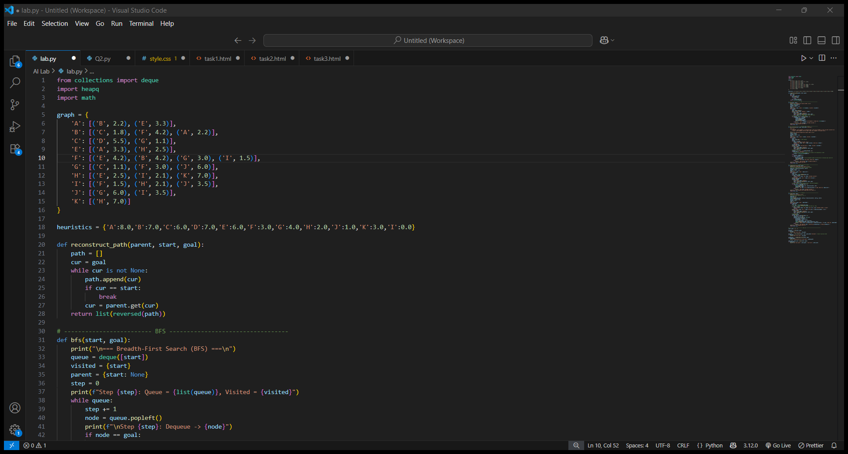

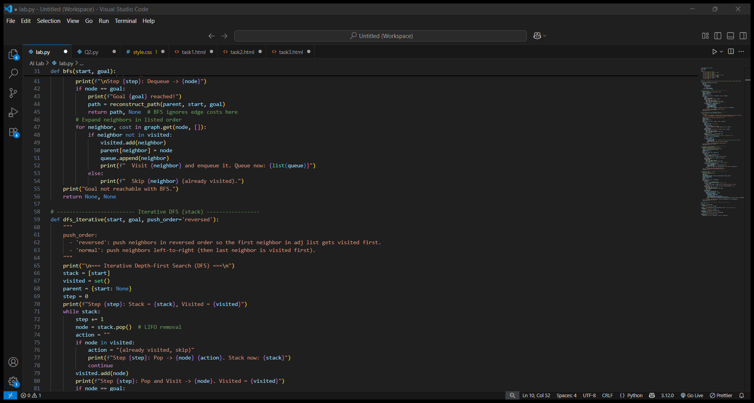

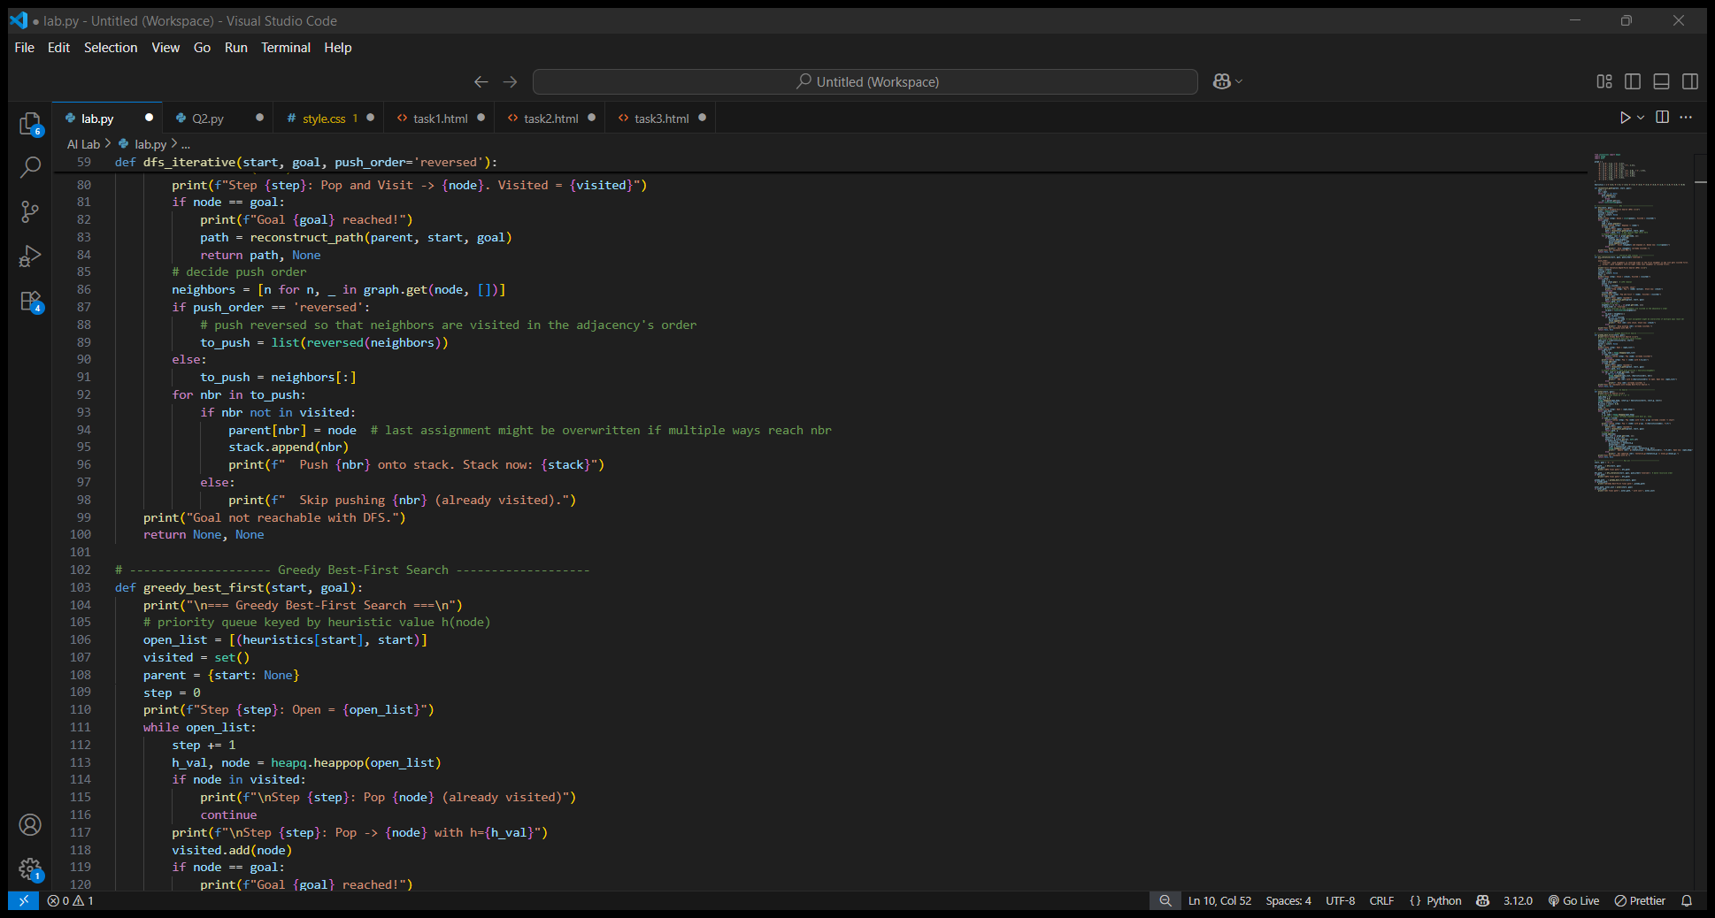

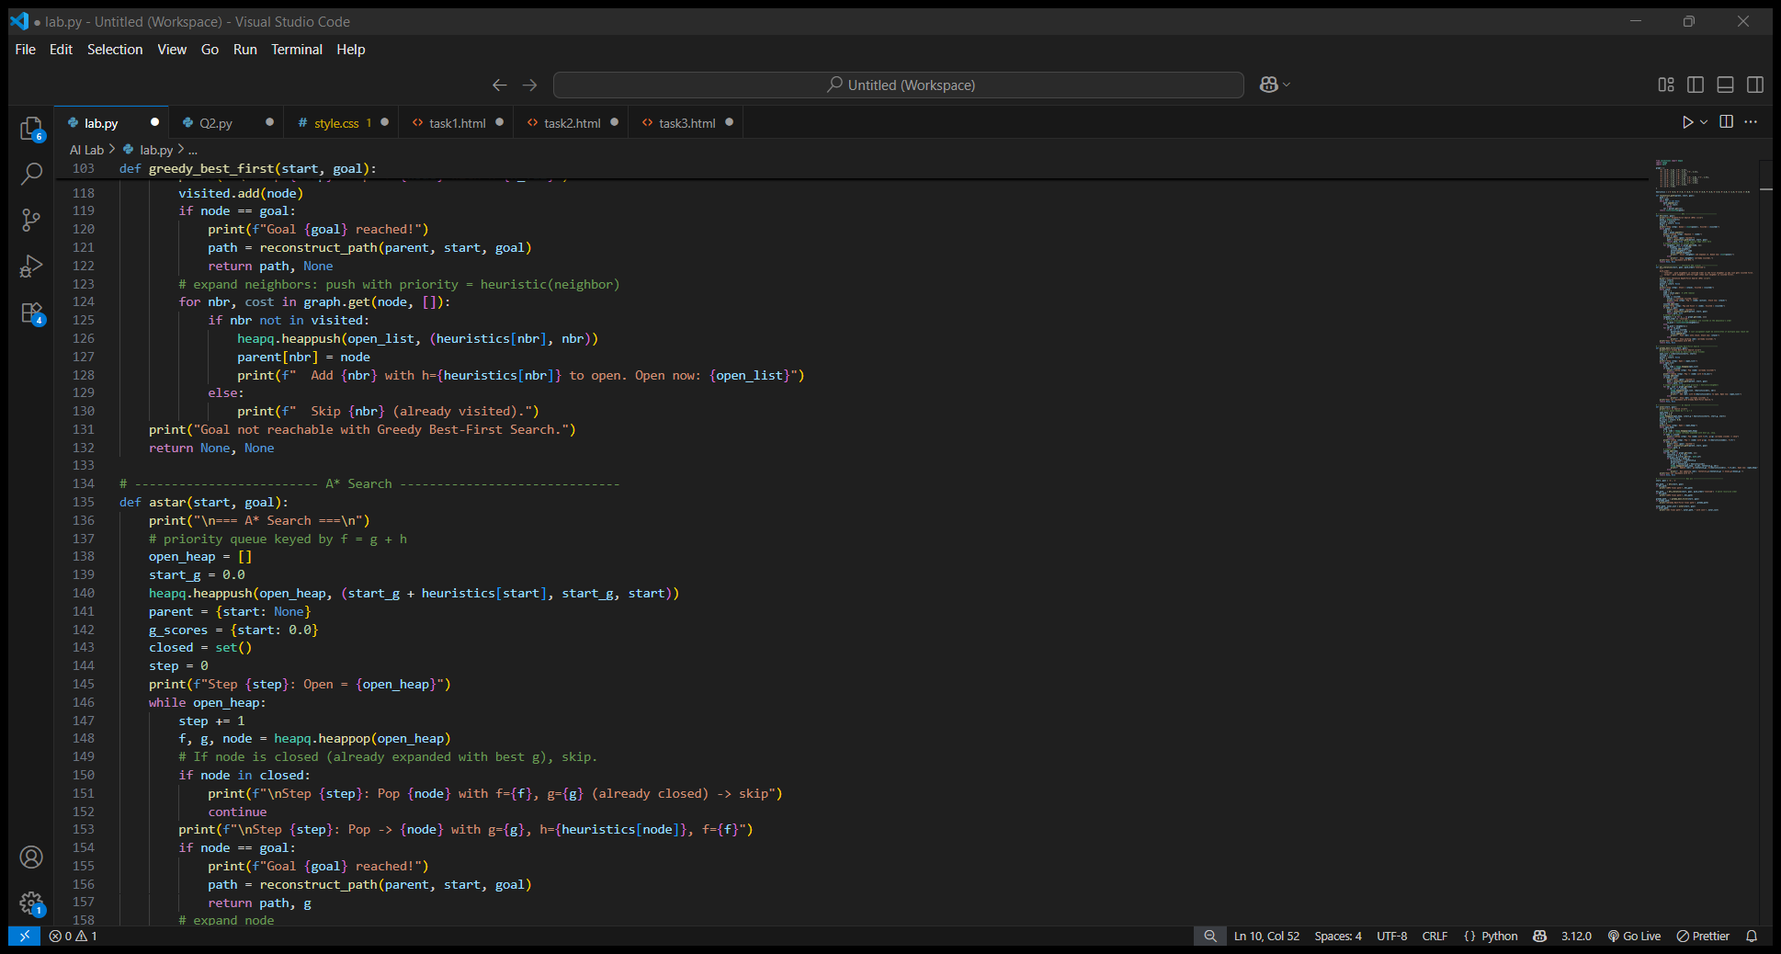

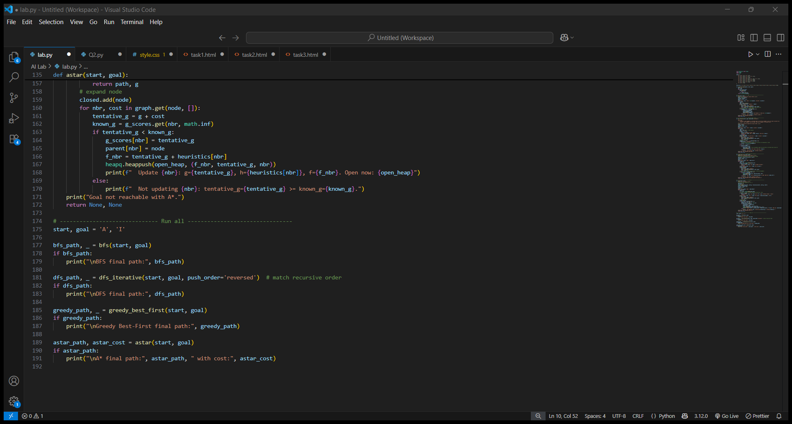

Output

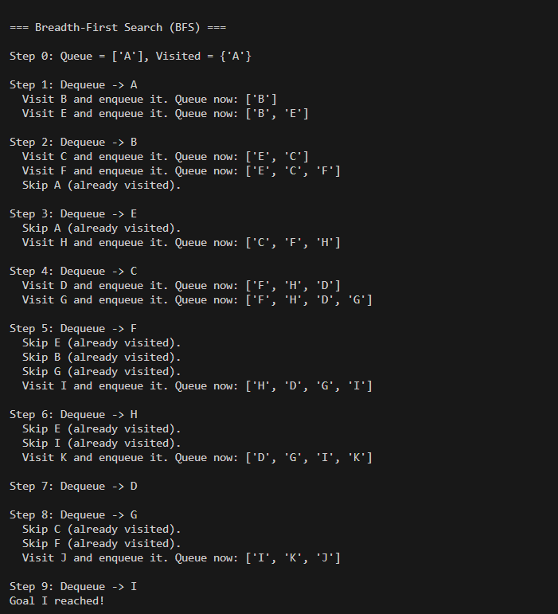

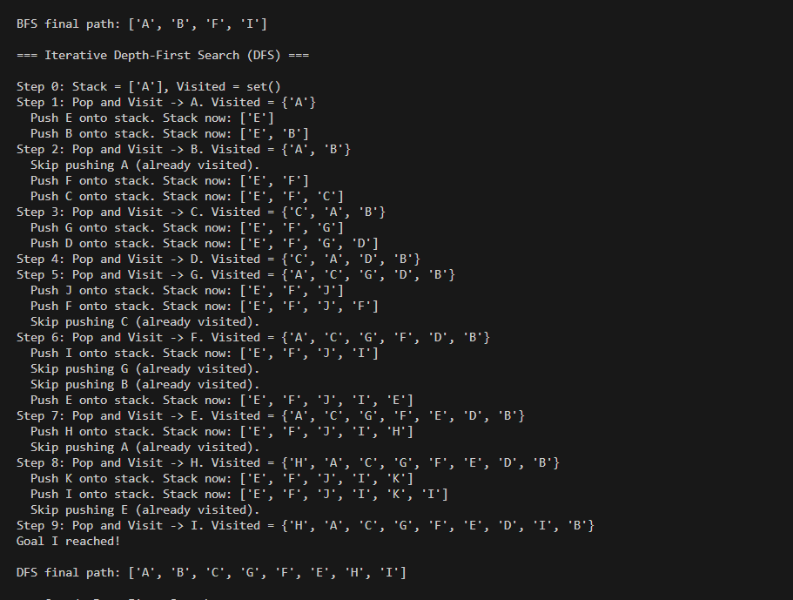

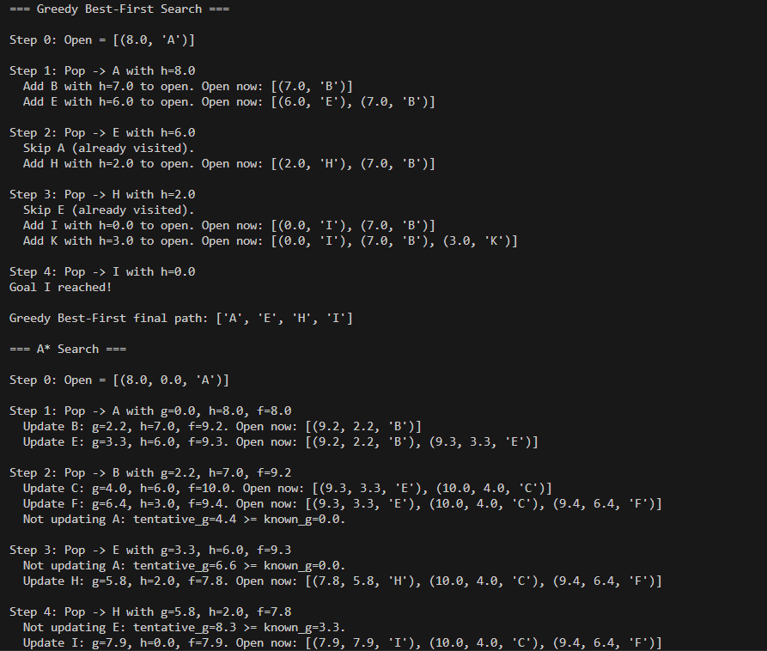

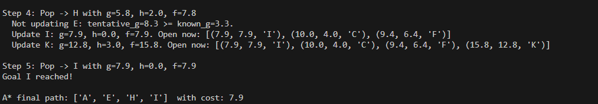

Question #2

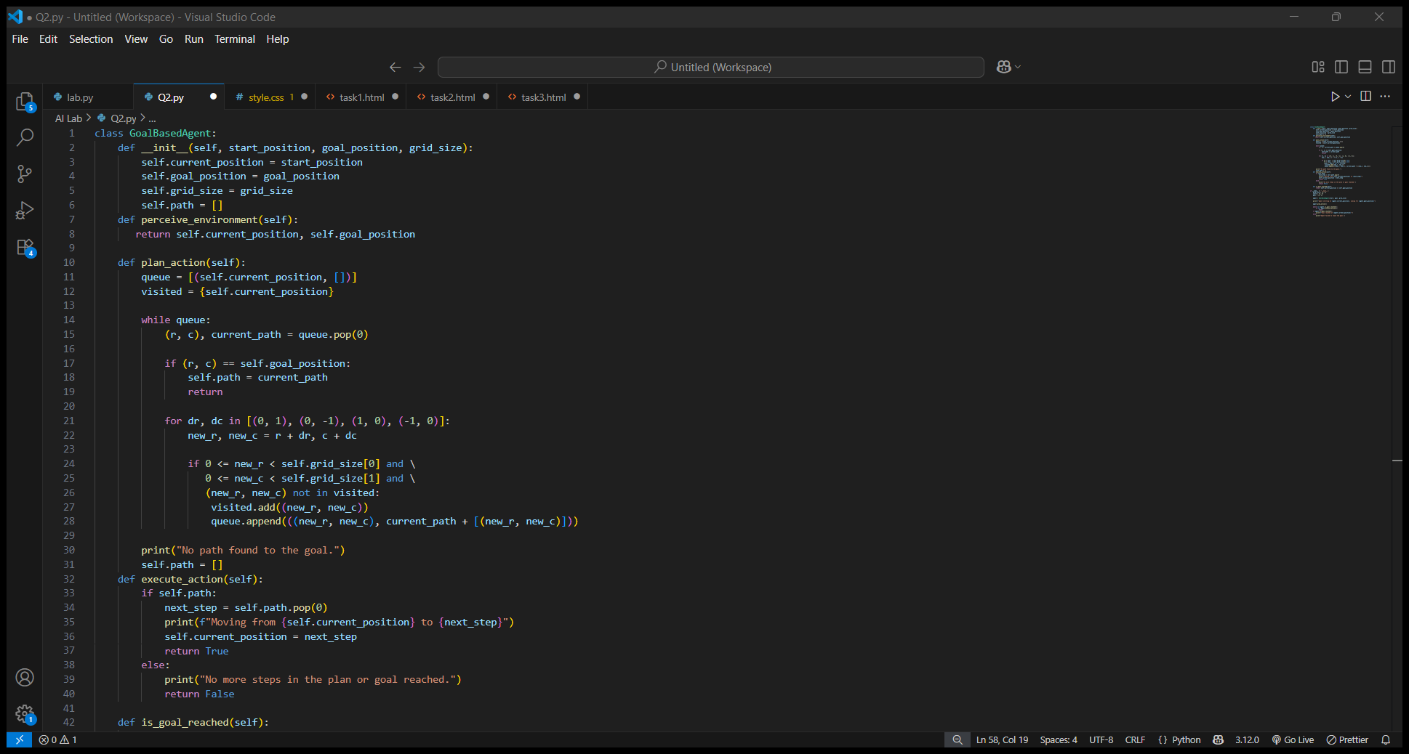

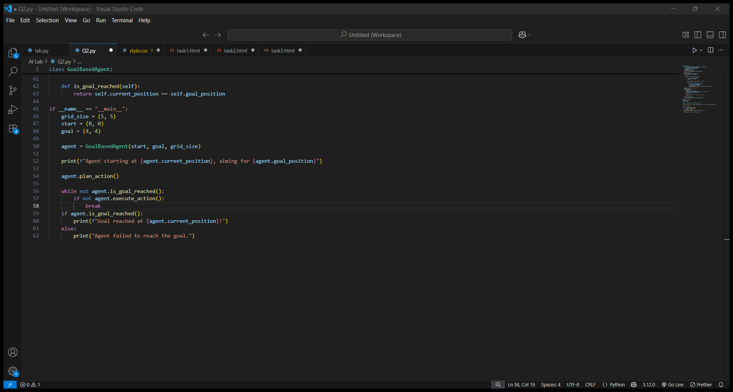

Output

